Chapter 12 Thermodynamics & Electrochemistry name: class:
考点 A: 氧化还原 (Redox) — oxidation numbers, balancing redox, half-reactions
Oxidation: loss of electrons (increase in oxidation number); Reduction: gain of electrons (decrease in oxidation number)
Half-reaction method: balance atoms first, then balance charge with e⁻
Oxidation number rules: free elements = 0; monatomic ions = ionic charge; H = +1 (except hydrides); O = -2 (except peroxides)
考点 B: 原电池 (Galvanic/Voltaic Cells) — cell potential, electrodes, salt bridge
1. 掌握原电池（Galvanic cell）和电池电动势
Galvanic cell: spontaneous redox reaction produces electrical energy
Anode (-): oxidation; Cathode (+): reduction; Electrons flow from anode → cathode
E°cell = E°cathode − E°anode (both as reduction potentials); E°cell > 0 → spontaneous
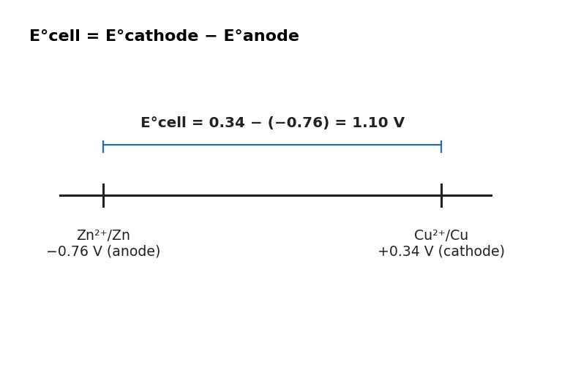
图 C₁2-2：电池电动势计算示意（E°cell = E°cathode − E°anode）
ΔG° = −nFE°; lnK = nFE°/RT

1. Zn|Zn²⁺(1.0M)||Cu²⁺(1.0M)|Cu. E°: Zn²⁺/Zn=−0.76V, Cu²⁺/Cu=+0.34V. E°cell = ? （ ）
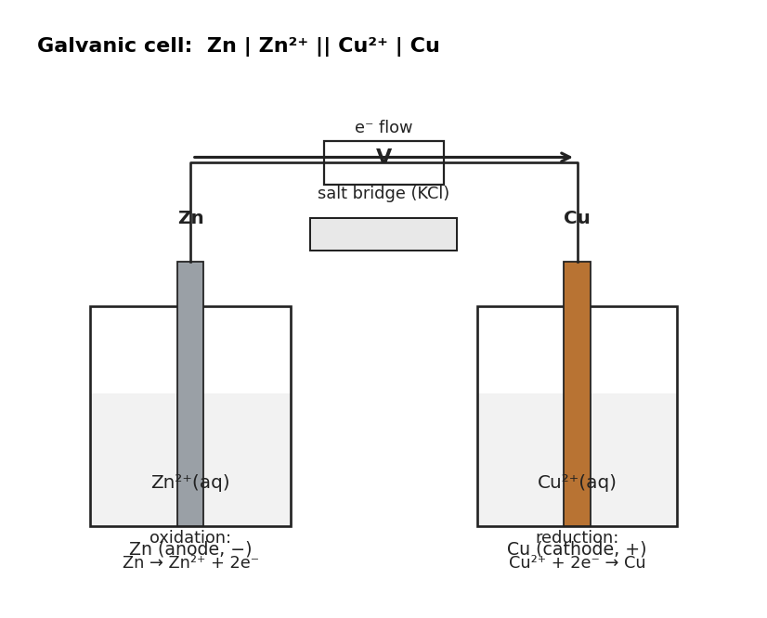
图 C₁2-1：Zn-Cu 原电池装置示意图（对应考点 B MCQ1）
A 0.42 V
B 1.10 V
C −0.42 V
D −1.10 V

2. In the above cell, electrons flow: （ ）
A from Cu to Zn through the wire.
B from Zn to Cu through the wire.
C from Cu to Zn through the salt bridge.
D from Zn²⁺ to Cu²⁺ in solution.

3. For Zn + Cu²⁺ → Zn²⁺ + Cu, n=2, E°cell=1.10V, F=96485. ΔG° = ? （ ）
A −106 kJ/mol
B −212 kJ/mol
C +106 kJ/mol
D +212 kJ/mol

4. The difference between a galvanic cell and an electrolytic cell is that （ ）
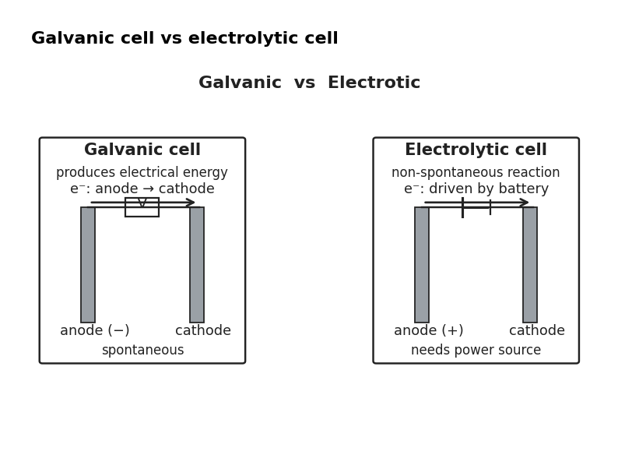
图 C₁2-3：原电池与电解池对比（对应考点 B/C MCQ4）
A. a galvanic cell requires an external power source, while an electrolytic cell does not.
B. oxidation occurs at the anode in a galvanic cell and at the cathode in an electrolytic cell.
C. a galvanic cell produces electrical energy from a spontaneous reaction, while an electrolytic cell requires electrical energy to drive a non-spontaneous reaction.
D. the flow of electrons is from the cathode to the anode in a galvanic cell, but from the anode to the cathode in an electrolytic cell.

5. Given:
Ni²⁺ (aq) + 2e⁻ → Ni (s), E° = −0.25 V;
Au³⁺ (aq) + 3e⁻ → Au (s), E° = +1.50 V.
Based on the information in the table above, which of the following shows the cell potential and the Gibbs free energy change for the overall reaction that occurs in a standard galvanic cell? （ ）
A. E°cell = +1.75 V; ΔG° = −169 kJ mol⁻¹
B. E°cell = +1.75 V; ΔG° = −1013 kJ mol⁻¹
C. E°cell = +2.25 V; ΔG° = −217 kJ mol⁻¹
D. E°cell = +2.25 V; ΔG° = +1302 kJ mol⁻¹

6. A galvanic cell has a standard cell potential of +0.76 V at 25°C.
Assuming 2 electrons are transferred, what is the equilibrium constant for the cell reaction? （ ）
A. Option A
B. Option B
C. Option C
D. Option D

7. A student sets up a galvanic cell that has a Pt (s) electrode and a Cu (s) electrode.
The half-reactions that occur at each electrode are:
Pt (s):
Cr²⁺ (aq) → Cr³⁺ (aq) + e⁻;
Cu (s):
Cu²⁺ (aq) + 2e⁻ → Cu (s).
Which of the following correctly describes what happens to the mass of each electrode as the cell operates? （ ）
A. The mass of the Cu (s) electrode increases, and the mass of the Pt (s) electrode remains the same.
B. The mass of the Pt (s) electrode increases, and the mass of the Cu (s) electrode remains the same.
C. The mass of the Cu (s) and Pt (s) electrodes both increase.
D. The mass of the Cu (s) and Pt (s) electrodes both remain the same.

8. Given:
Ni²⁺ (aq) + 2e⁻ → Ni (s), E° = −0.25 V;
Fe²⁺ (aq) + 2e⁻ → Fe (s), E° = −0.44 V.
Which of the following gives the value of E°cell for the cell? （ ）
A. Option A
B. Option B
C. Option C
D. Option D

9. For the reaction 2Ag⁺ + Cd → Ag + Cd²⁺ the standard cell potential is +0.82 V.
What is the equilibrium constant for this reaction at 45°C? （ ）
A. Option A⁻²⁶
B. Option B
C. Option C
D. Option D

10. Given:
Hg²⁺ (aq) + 2e⁻ → Hg (s), E° = +0.79 V;
Cu²⁺ (aq) + 2e⁻ → Cu (s), E° = +0.34 V;
Sn²⁺ (aq) + 2e⁻ → Sn (s), E° = −0.14 V;
Mn²⁺ (aq) + 2e⁻ → Mn (s), E° = −1.18 V. A standard galvanic cell is made using Sn-Sn(NO₃)₂ and Cu-Cu(NO₃)₂ half-cells.
Which of the following modifications to the cell will cause the greatest increase in E°cell?
Assume all solutions are 1 M. （ ）
A. Replacing the Cu-Cu(NO₃)₂ half-cell with a Hg-Hg(NO₃)₂ half-cell.
B. Replacing the Cu-Cu(NO₃)₂ half-cell with a Mn-Mn(NO₃)₂ half-cell.
C. Replacing the Sn-Sn(NO₃)₂ half-cell with a Hg-Hg(NO₃)₂ half-cell.
D. Replacing the Sn-Sn(NO₃)₂ half-cell with a Mn-Mn(NO₃)₂ half-cell.

11. Zn (s) + Cu²⁺ (aq) → Zn²⁺ (aq) + Cu (s).
What is the standard Gibbs free energy change (ΔG°) for the above reaction at 25°C, given the standard cell potential is 1.10 V? （ ）
A. Option A⁻¹
B. Option B⁻¹
C. Option C⁻¹
D. Option D⁻¹

12. Al|Al³⁺ and Ag|Ag⁺ cell. E°: Al³⁺/Al=−1.66V, Ag⁺/Ag=+0.80V.
(a) Write the balanced net ionic equation. [1 mark]
(b) Calculate E°cell and ΔG° (n=3). [2 marks]
(c) Which electrode decreases in mass? Explain. [1 mark]

考点 C: 电解池 (Electrolytic Cells) — electrolysis, Faraday's law
3. 掌握电解和 Faraday 定律
Electrolysis (电解): non-spontaneous reaction driven by external power source
Faraday: moles of e⁻ = It/F (I in A, t in s, F=96485 C/mol)
Mass deposited = n(e⁻) × (M/n_f) where n_f = electrons per ion

1. During electrolysis of molten MgCl₂, the cathode reaction is: （ ）
A 2Cl⁻ → Cl₂ + 2e⁻
B Mg²⁺ + 2e⁻ → Mg
C 2H₂O → O₂ + 4H⁺ + 4e⁻
D Mg → Mg²⁺ + 2e⁻

2. In an electrolytic cell used to electrolyze molten NaCl, what happens at the cathode? （ ）
A. Dissolution of the electrode.
B. Evolution of chlorine gas.
C. Oxidation of chloride ions.
D. Reduction of sodium ions.

3. In an electrolytic cell, a current of 2.5 A is passed through a solution of CuSO₄ for 30 minutes.
How many grams of copper will be deposited at the cathode? （ ）
A. Option A
B. Option B
C. Option C
D. Option D

4. An experiment is set up to determine the value of the Faraday constant by electrolyzing dilute sulfuric acid.
Which experimental measurement is not required to calculate a value for the Faraday constant? （ ）
A. Option A
B. Option B
C. Option C
D. Option D

5. A current of 1.5 A is passed through molten AlCl₃ for 2 hours.
What volume of chlorine gas (measured at STP) is produced at the anode? （ ）
A. Option A
B. Option B
C. Option C
D. Option D

6. Which of the following electrolytic cells would give the greatest mass of metal at the cathode? （ ）
A. Current = 1.0 A, Time = 750 s, 1.0 M CuSO₄ (aq)
B. Current = 1.0 A, Time = 500 s, 1.0 M CuSO₄ (aq)
C. Current = 1.5 A, Time = 250 s, 1.0 M AgNO₃ (aq)
D. Current = 2.0 A, Time = 250 s, 1.0 M AgNO₃ (aq)

7. CuCl₂ (l) → Cu (l) + Cl₂ (g).
In an electrolytic cell based on the reaction represented above, which of the following describes the process at the anode? （ ）
A. Chlorine is oxidized.
B. Option B
C. Option C
D. Option D

8. Molten MgCl₂ electrolyzed at 3.00 A for 2.00 hours. (F=96485, Mg=24.31)
(a) Calculate the mass of Mg produced. [3 marks]

9. A CuSO₄ solution is electrolyzed. 2.50 A deposits 0.495 g Cu. (Cu=63.55)
(a) Calculate the time in seconds. [3 marks]

考点 D: 能斯特方程 (Nernst Equation) — E=E°−RT/nF lnQ, concentration cells
2. 掌握 Nernst 方程（非标况）
Nernst: E = E° − (0.0592/n) logQ at 25°C
As cell discharges, Q increases → E decreases → eventually E=0 at equilibrium

1. For Zn/Cu cell with [Zn²⁺]=0.100M, [Cu²⁺]=0.0100M, E°cell=1.10V. Ecell ≈ ? （ ）
A 1.13 V
B 1.07 V
C 1.10 V
D 0.97 V

2. A galvanic cell is constructed with a Zn electrode in 0.1 M Zn²⁺ solution and a Cu electrode in 0.01 M Cu²⁺ solution.
Given E°(Cu²⁺/Cu) = +0.34 V and E°(Zn²⁺/Zn) = −0.76 V, what is the cell potential at 25°C? （ ）
A. Option A
B. Option B
C. Option C
D. Option D

考点 E: 熵 (Entropy) — CED Topics 9.1-9.2
熵 (S) 是系统混乱度/微观状态数的度量; 气态 > 液态 > 固态
ΔS > 0 表示熵增 (more disordered); ΔS < 0 表示熵减 (more ordered)
影响熵变的因素: 物态变化 (s→l→g 熵增), 温度升高, 粒子数增加
标准熵 S° 是绝对量 (第三定律: 完美晶体在0K时 S=0), S° 恒为正值
反应熵变: ΔS° = ΣS°(产物) − ΣS°(反应物)

1. For which of the following processes is ΔS most likely positive? （ ）
A H₂O(l) → H₂O(s)
B 2NO₂(g) → N₂O₄(g)
C CaCO₃(s) → CaO(s) + CO₂(g)
D NH₃(g) + HCl(g) → NH₄Cl(s)

2. For N₂(g) + 3H₂(g) → 2NH₃(g), the sign of ΔS° is: （ ）
A positive (more moles of gas produced).
B negative (fewer moles of gas on product side).
C approximately zero.
D cannot be predicted without S° values.

3. Given: S°(Na(s)) = 51.2, S°(Cl₂(g)) = 223.0, S°(NaCl(s)) = 72.1 J/mol·K.
For 2Na(s) + Cl₂(g) → 2NaCl(s), calculate ΔS°. （ ）
A −181.1 J/K
B −362.2 J/K
C +181.1 J/K
D +362.2 J/K

4. Which of the following correctly describes the entropy change for the sublimation of dry ice (CO₂(s) → CO₂(g))? （ ）
A ΔS > 0 because the gas molecules have more freedom of motion than the solid.
B ΔS < 0 because the solid has a more ordered structure.
C ΔS = 0 because sublimation occurs at constant temperature.
D ΔS cannot be determined without knowing the enthalpy change.

5. For the reaction: 2C(s) + O₂(g) → 2CO(g), ΔS° = +179 J/K at 298 K.
Given S°(CO(g)) = 197.7 J/mol·K, S°(O₂(g)) = 205.1 J/mol·K.
(a) Explain why ΔS° is positive for this reaction. [1 mark]
(b) Calculate S°(C(s, graphite)). [1 mark]

考点 F: Gibbs自由能与热力学自发性 (Gibbs Free Energy & Thermodynamic Favorability) — CED Topics 9.3-9.5
Gibbs自由能: ΔG = ΔH − TΔS; ΔG < 0 反应热力学有利 (spontaneous/thermodynamically favored)
四种情况: ΔH<0,ΔS>0 → 任何温度自发; ΔH>0,ΔS<0 → 任何温度非自发; ΔH<0,ΔS<0 → 低温自发; ΔH>0,ΔS>0 → 高温自发
转换温度: T = ΔH/ΔS (where ΔG = 0)
ΔG° = −RT ln K; K > 1 ↔ ΔG° < 0 (热力学有利)
ΔG = ΔG° + RT ln Q (非标准条件)

1. For a reaction with ΔH° < 0 and ΔS° > 0, which is true? （ ）
A The reaction is spontaneous at all temperatures.
B The reaction is non-spontaneous at all temperatures.
C The reaction is spontaneous only at low temperatures.
D The reaction is spontaneous only at high temperatures.

2. For H₂O(l) → H₂O(g): ΔH° = +40.7 kJ/mol, ΔS° = +109 J/mol·K. At what temperature does ΔG° = 0? （ ）
A 273 K
B 373 K
C 298 K
D 310 K

3. For 2NO₂(g) → N₂O₄(g): ΔH° = −57.2 kJ/mol, ΔS° = −175.8 J/mol·K. Calculate ΔG° at 298 K. （ ）
A −4.8 kJ/mol (favorable)
B +4.8 kJ/mol (not favorable)
C −110 kJ/mol
D 0 kJ/mol

4. A reaction has ΔG° = −15.0 kJ/mol at 298 K. What is the value of K? （ ）
A K ≈ 1.8 × 10²
B K ≈ 4.2 × 10⁻³
C K ≈ 1
D K ≈ 6.0 × 10⁵

5. For CaCO₃(s) → CaO(s) + CO₂(g): ΔH° = +178 kJ/mol, ΔS° = +160 J/mol·K.
Is the reaction thermodynamically favored at 298 K? （ ）
A Yes, because ΔH > 0.
B Yes, because ΔG = ΔH − TΔS = 178 − 298(0.160) = +130.3 kJ > 0, so not favored.
C No, because ΔG° > 0 at 298 K. (The reaction becomes favorable above T = ΔH/ΔS ≈ 1113 K.)
D Cannot be determined without knowing the equilibrium constant.

6. The reaction N₂(g) + 3H₂(g) → 2NH₃(g) has ΔG° = −33.0 kJ/mol at 298 K.
What is the value of Kp at 298 K? (R = 8.314 J/mol·K) （ ）
A 1.2 × 10⁻⁶
B 8.3 × 10⁵
C 1.0
D 3.3 × 10¹⁰

7. For NH₄Cl(s) → NH₃(g) + HCl(g): ΔH° = +176 kJ/mol, ΔS° = +285 J/mol·K at 298 K.
(a) Calculate ΔG° at 298 K. [1 mark]
(b) Is the decomposition thermodynamically favored at 298 K? Justify. [1 mark]
(c) At what temperature does the reaction become thermodynamically favored? [1 mark]

8. The dissolution of ammonium nitrate: NH₄NO₃(s) → NH₄⁺(aq) + NO₃⁻(aq), ΔH° = +25.7 kJ/mol, ΔS° = +108.8 J/mol·K at 298 K.
(a) Calculate ΔG° for the dissolution at 298 K. [1 mark]
(b) Explain why the dissolution is thermodynamically favored despite being endothermic. [1 mark]

考点 G: 催化与偶联反应 (Catalysis and Coupled Reactions) — CED Topic 9.11
热力学有利 ≠ 反应实际发生: 还需要考虑活化能和反应速率
催化剂 (catalyst) 通过降低活化能提高反应速率, 但不改变 ΔG 或平衡位置
偶联反应 (coupled reactions): 将一个热力学不利的反应与一个有利的反应结合, 使总反应 ΔG < 0
实例: ATP水解 (ΔG° < 0) 偶联不利的生物合成反应; 碳酸钙分解偶联CO₂逸出

1. A reaction has ΔG° = −50 kJ/mol but does not proceed at room temperature. Which is the best explanation? （ ）
A The reaction is not thermodynamically favorable.
B The activation energy is too high for the reaction to occur at a measurable rate.
C The equilibrium constant is less than 1.
D The reaction violates the second law of thermodynamics.

2. Reaction 1: A → B, ΔG° = +30 kJ/mol (unfavorable).
Reaction 2: B → C, ΔG° = −50 kJ/mol (favorable).
If these reactions are coupled (A → C), what is ΔG° for the overall process? （ ）
A +80 kJ/mol
B +20 kJ/mol
C −20 kJ/mol
D −80 kJ/mol

3. Which of the following correctly describes the role of a catalyst in a chemical reaction? （ ）
A A catalyst decreases ΔG°, making the reaction more thermodynamically favorable.
B A catalyst increases K, shifting the equilibrium toward products.
C A catalyst lowers the activation energy, increasing the rate without changing ΔG° or K.
D A catalyst changes the reaction from endothermic to exothermic.

4. The Ostwald process couples nitrogen oxidation with subsequent steps.
Given: N₂(g) + O₂(g) → 2NO(g), ΔG° = +173.1 kJ/mol (unfavorable); 2NO(g) + O₂(g) → 2NO₂(g), ΔG° = −69.7 kJ/mol (favorable).
(a) Calculate ΔG° for the overall reaction: N₂(g) + 2O₂(g) → 2NO₂(g). [1 mark]
(b) Explain how coupling these reactions makes the overall process favorable. [1 mark]

